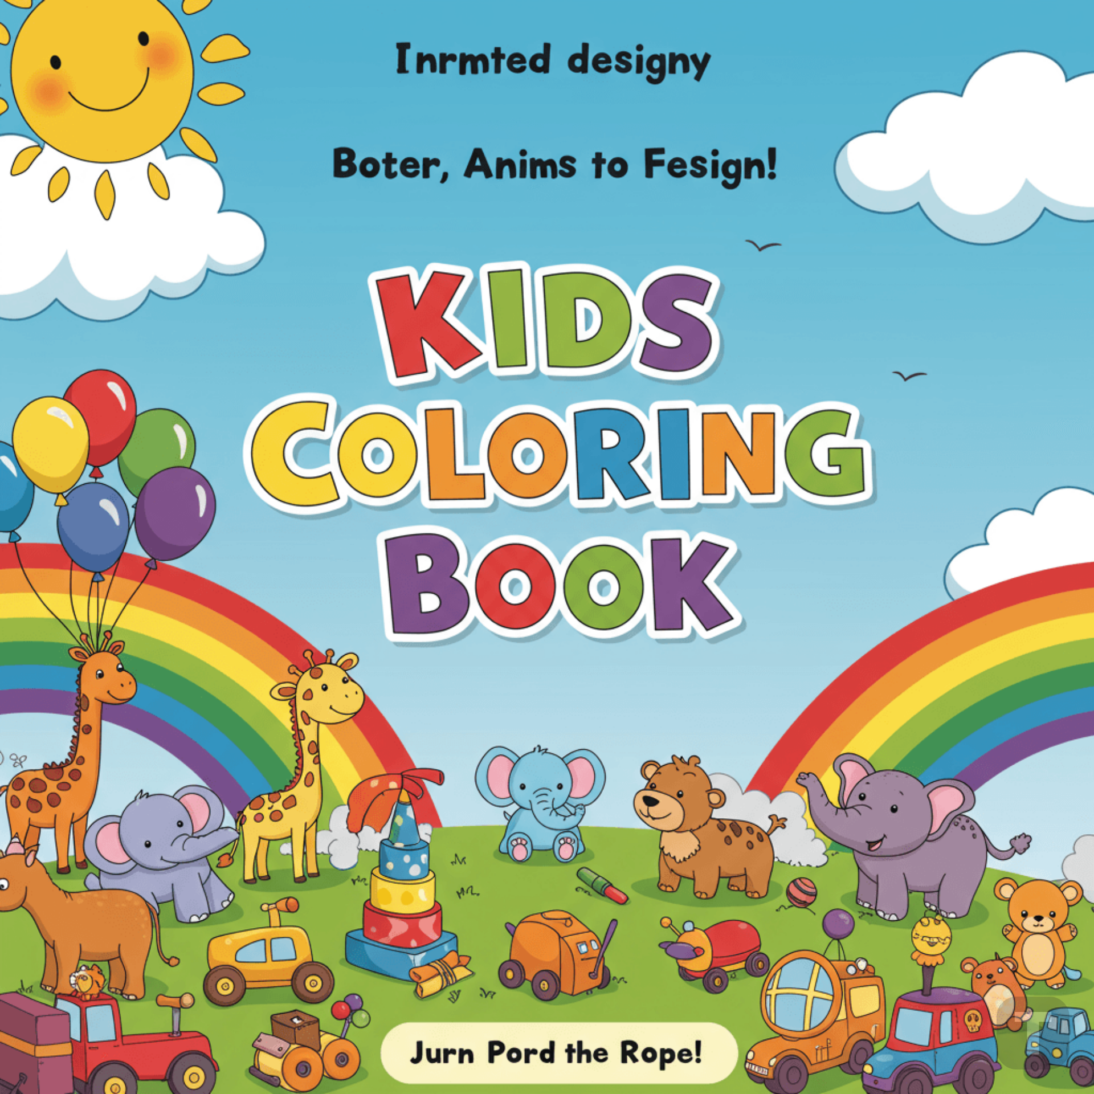



Table of CONTENTS

🐶 Animals 2

* Puppy chasing a butterfly 2
* Kitten in a teacup 3
* Jungle lion with a crown 4
* Elephant spraying water 5
* Farm scene with cow and tractor 6
* Penguin sliding on ice 7
* Koala hugging a tree 8
* Turtle with a backpack 9

🚗 **Vehicles**10

* Fire truck with a smiling face 10
* Airplane flying through clouds 11
* Sailboat on wavy sea 12
* Monster truck jumping over a hill 13
* School bus picking up kids 14

🧠 **Learning Concepts****15**

* Shapes and patterns coloring 15

👑 **Fantasy & Fun**16

* Unicorn dancing on a rainbow 16
* Castle with a dragon flying above 17
* Fairy in a flower garden 18
* Pirate ship with a treasure map 19
* Mermaid playing with sea creatures 20

🐶 **A N I M A L S**

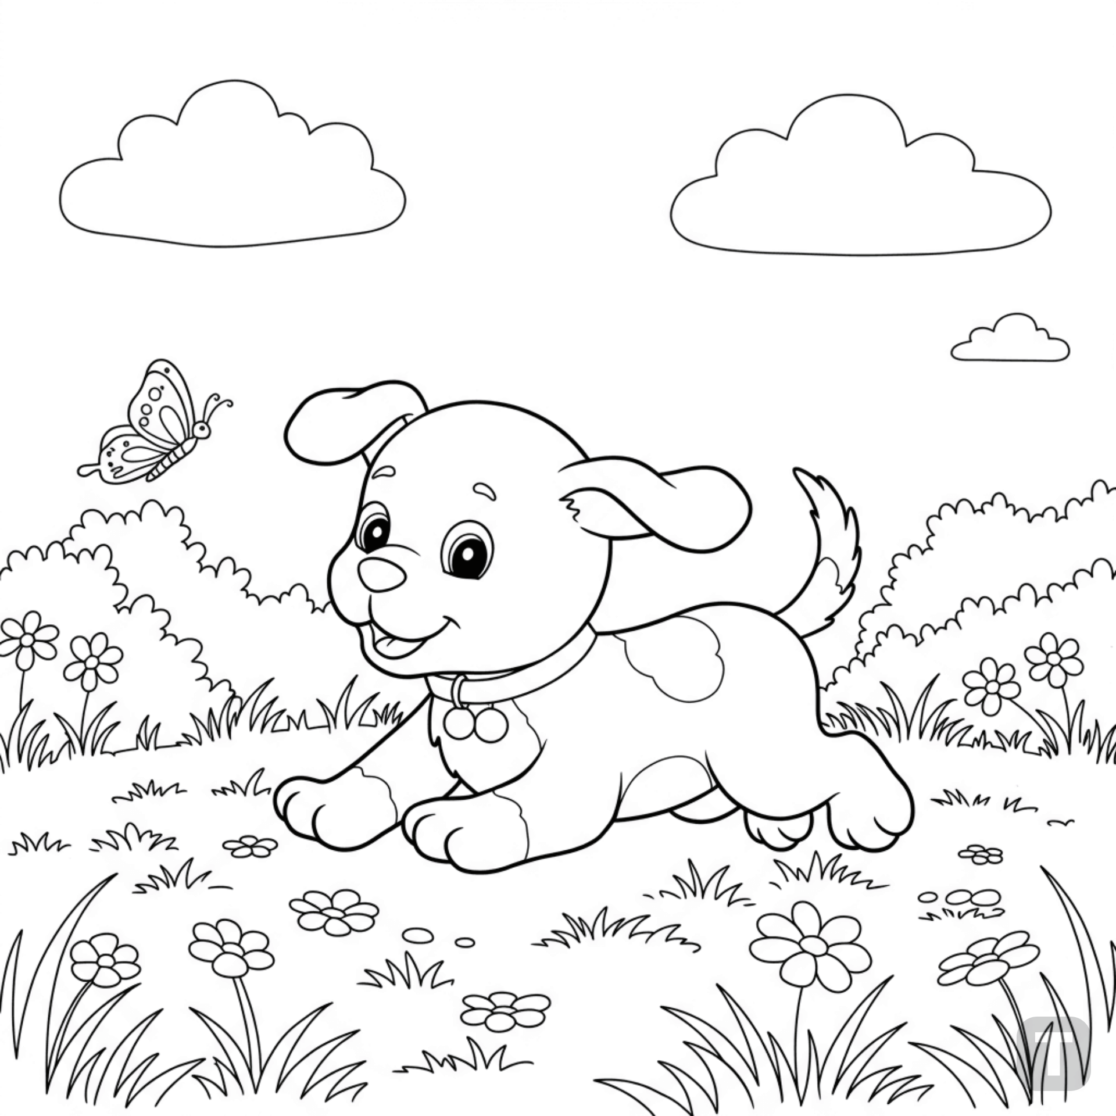

**Puppy chasing a butterfly**

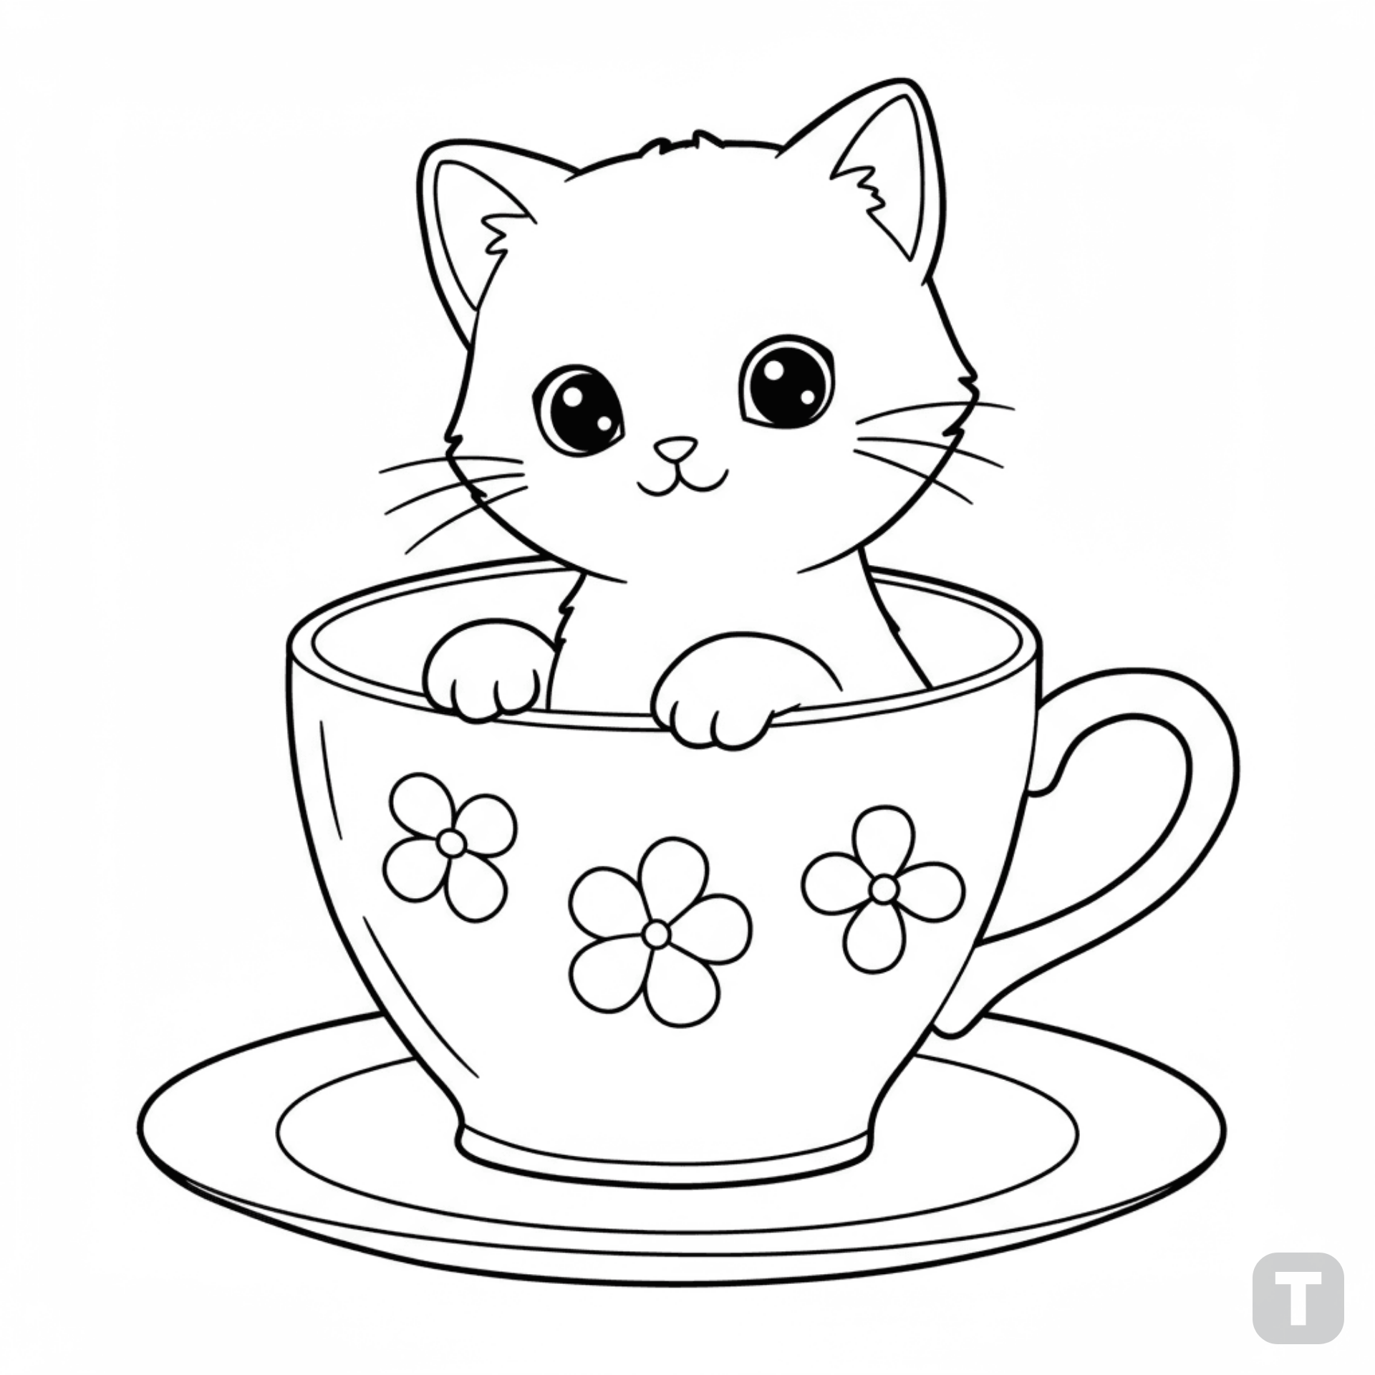

**Kitten in a teacup**

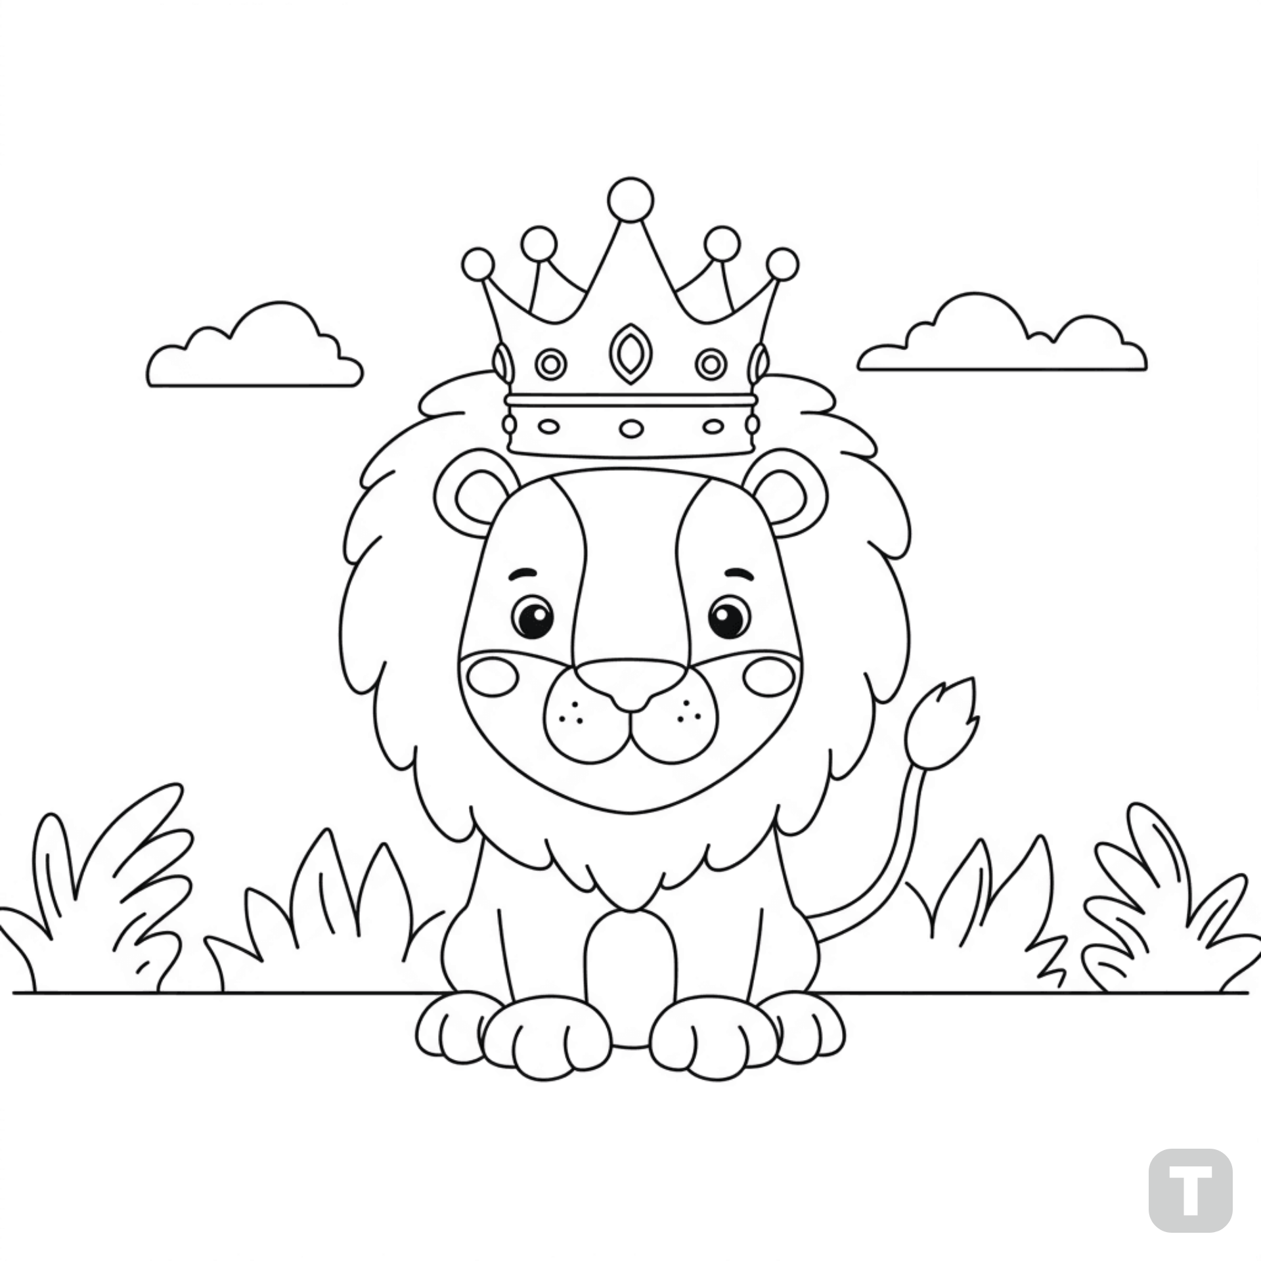

**Jungle lion with a crown**

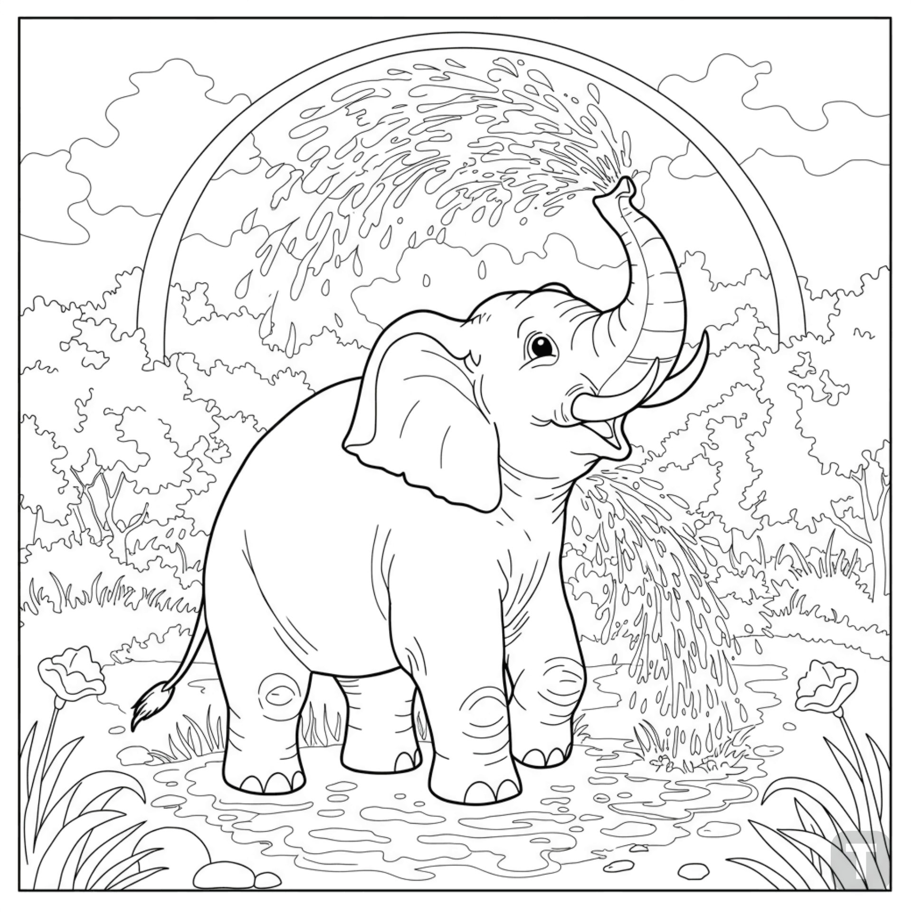

**Elephant spraying water**

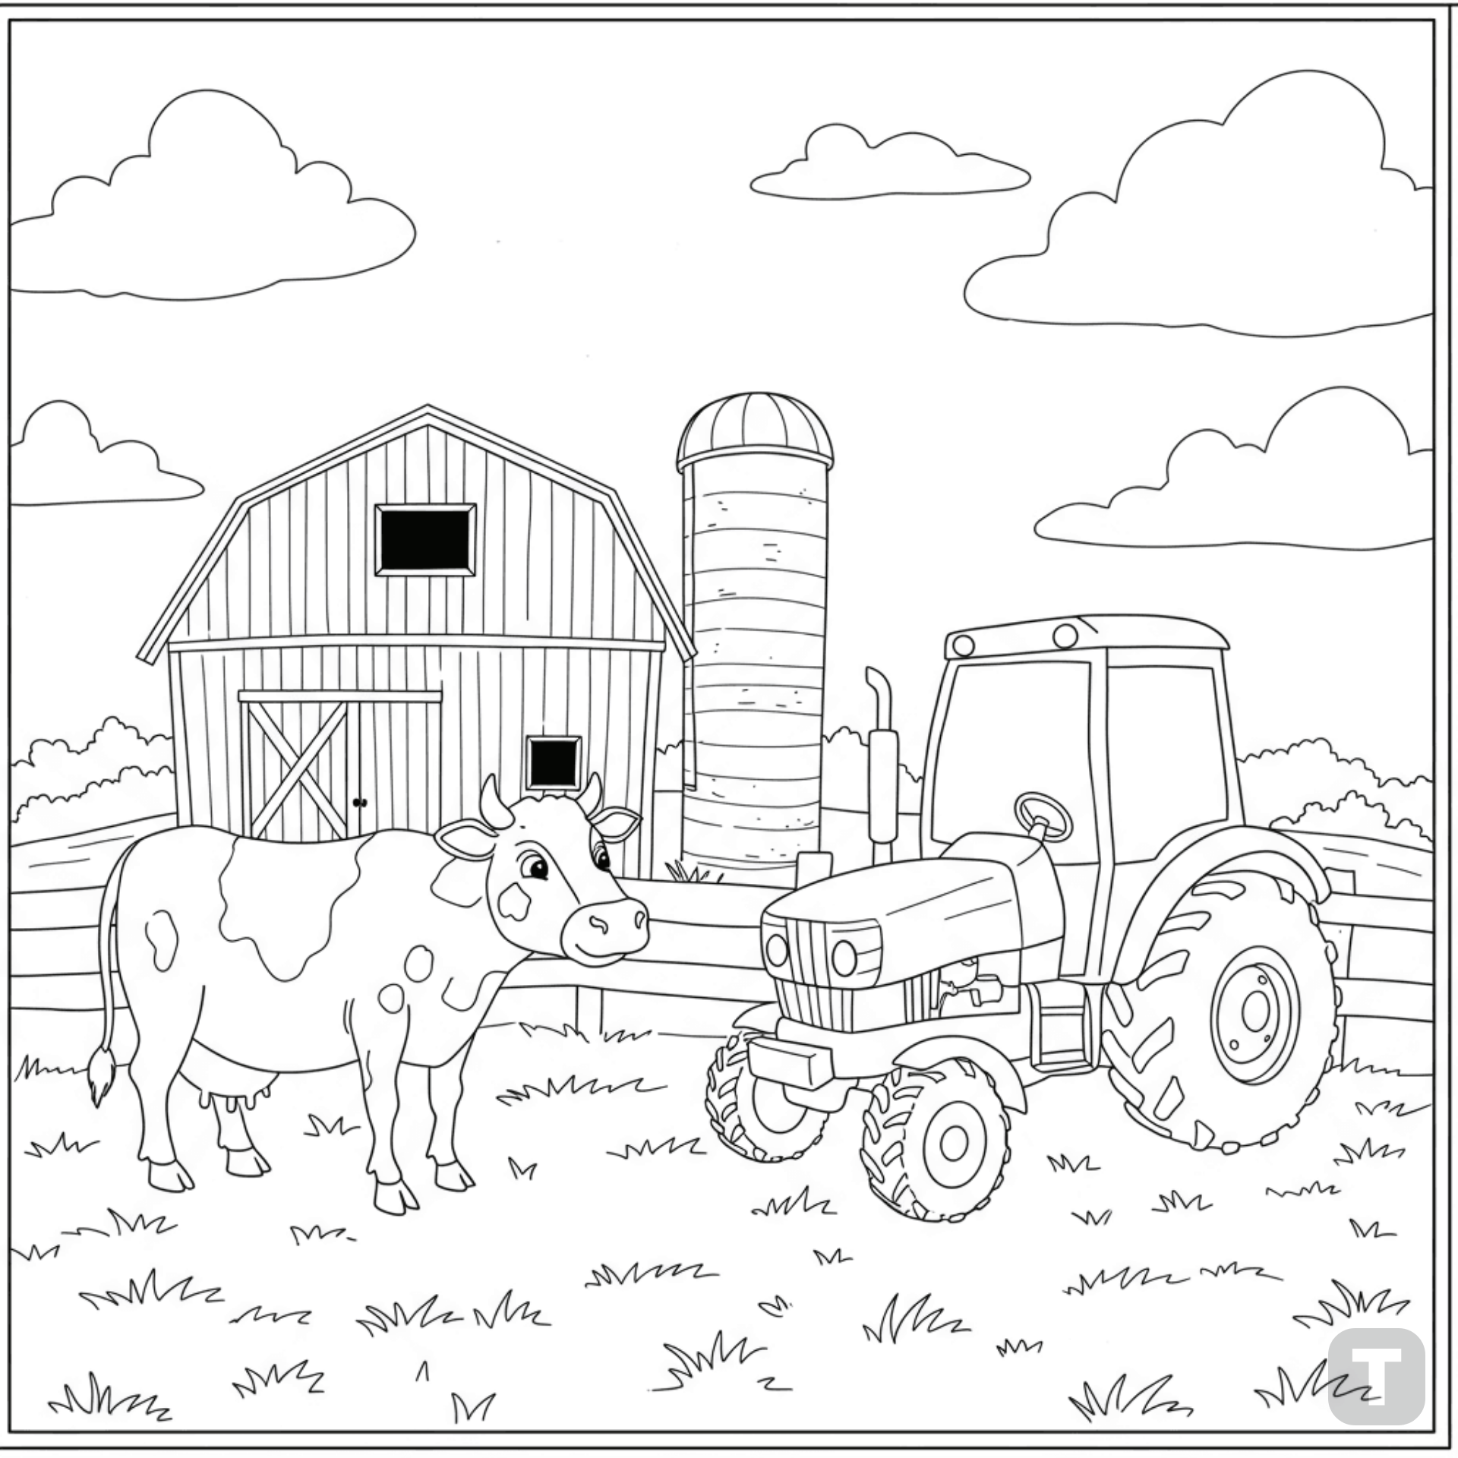

**Farm scene with cow and tractor**

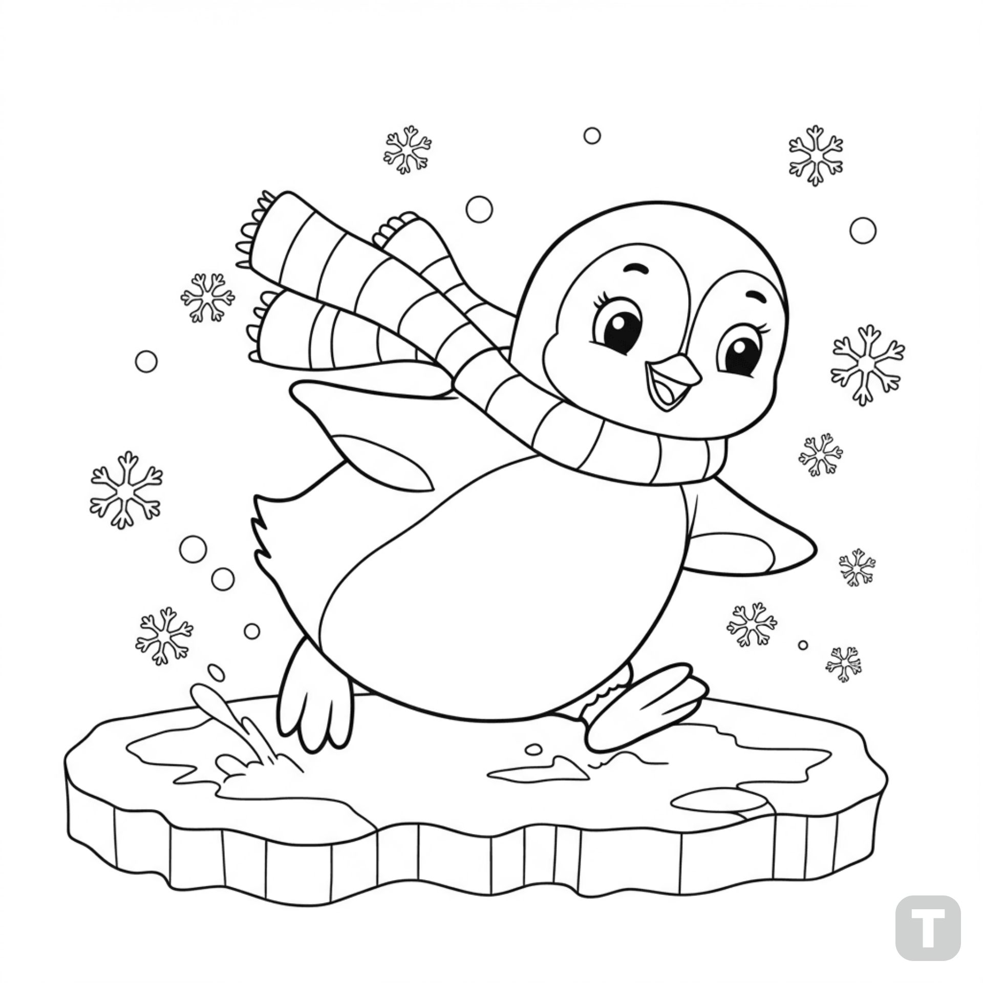

**Penguin sliding on ice**

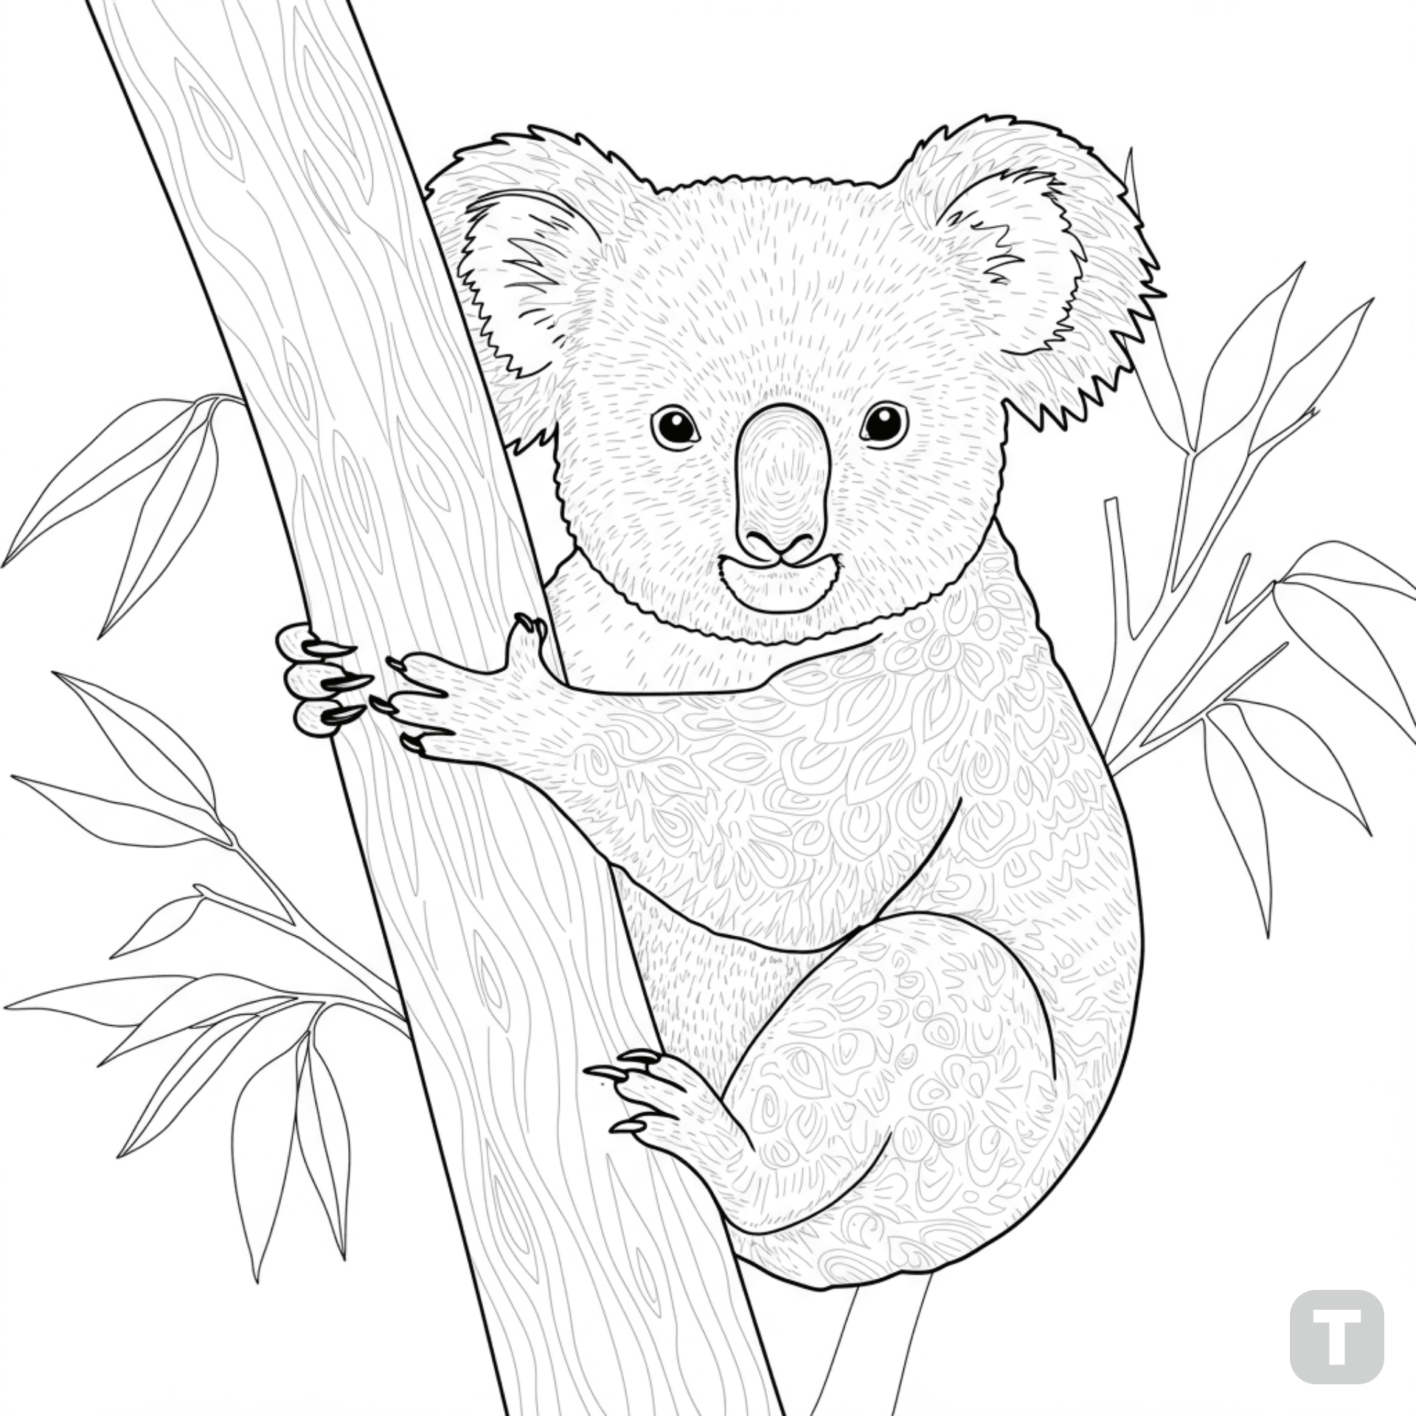

**Koala hugging a tree**

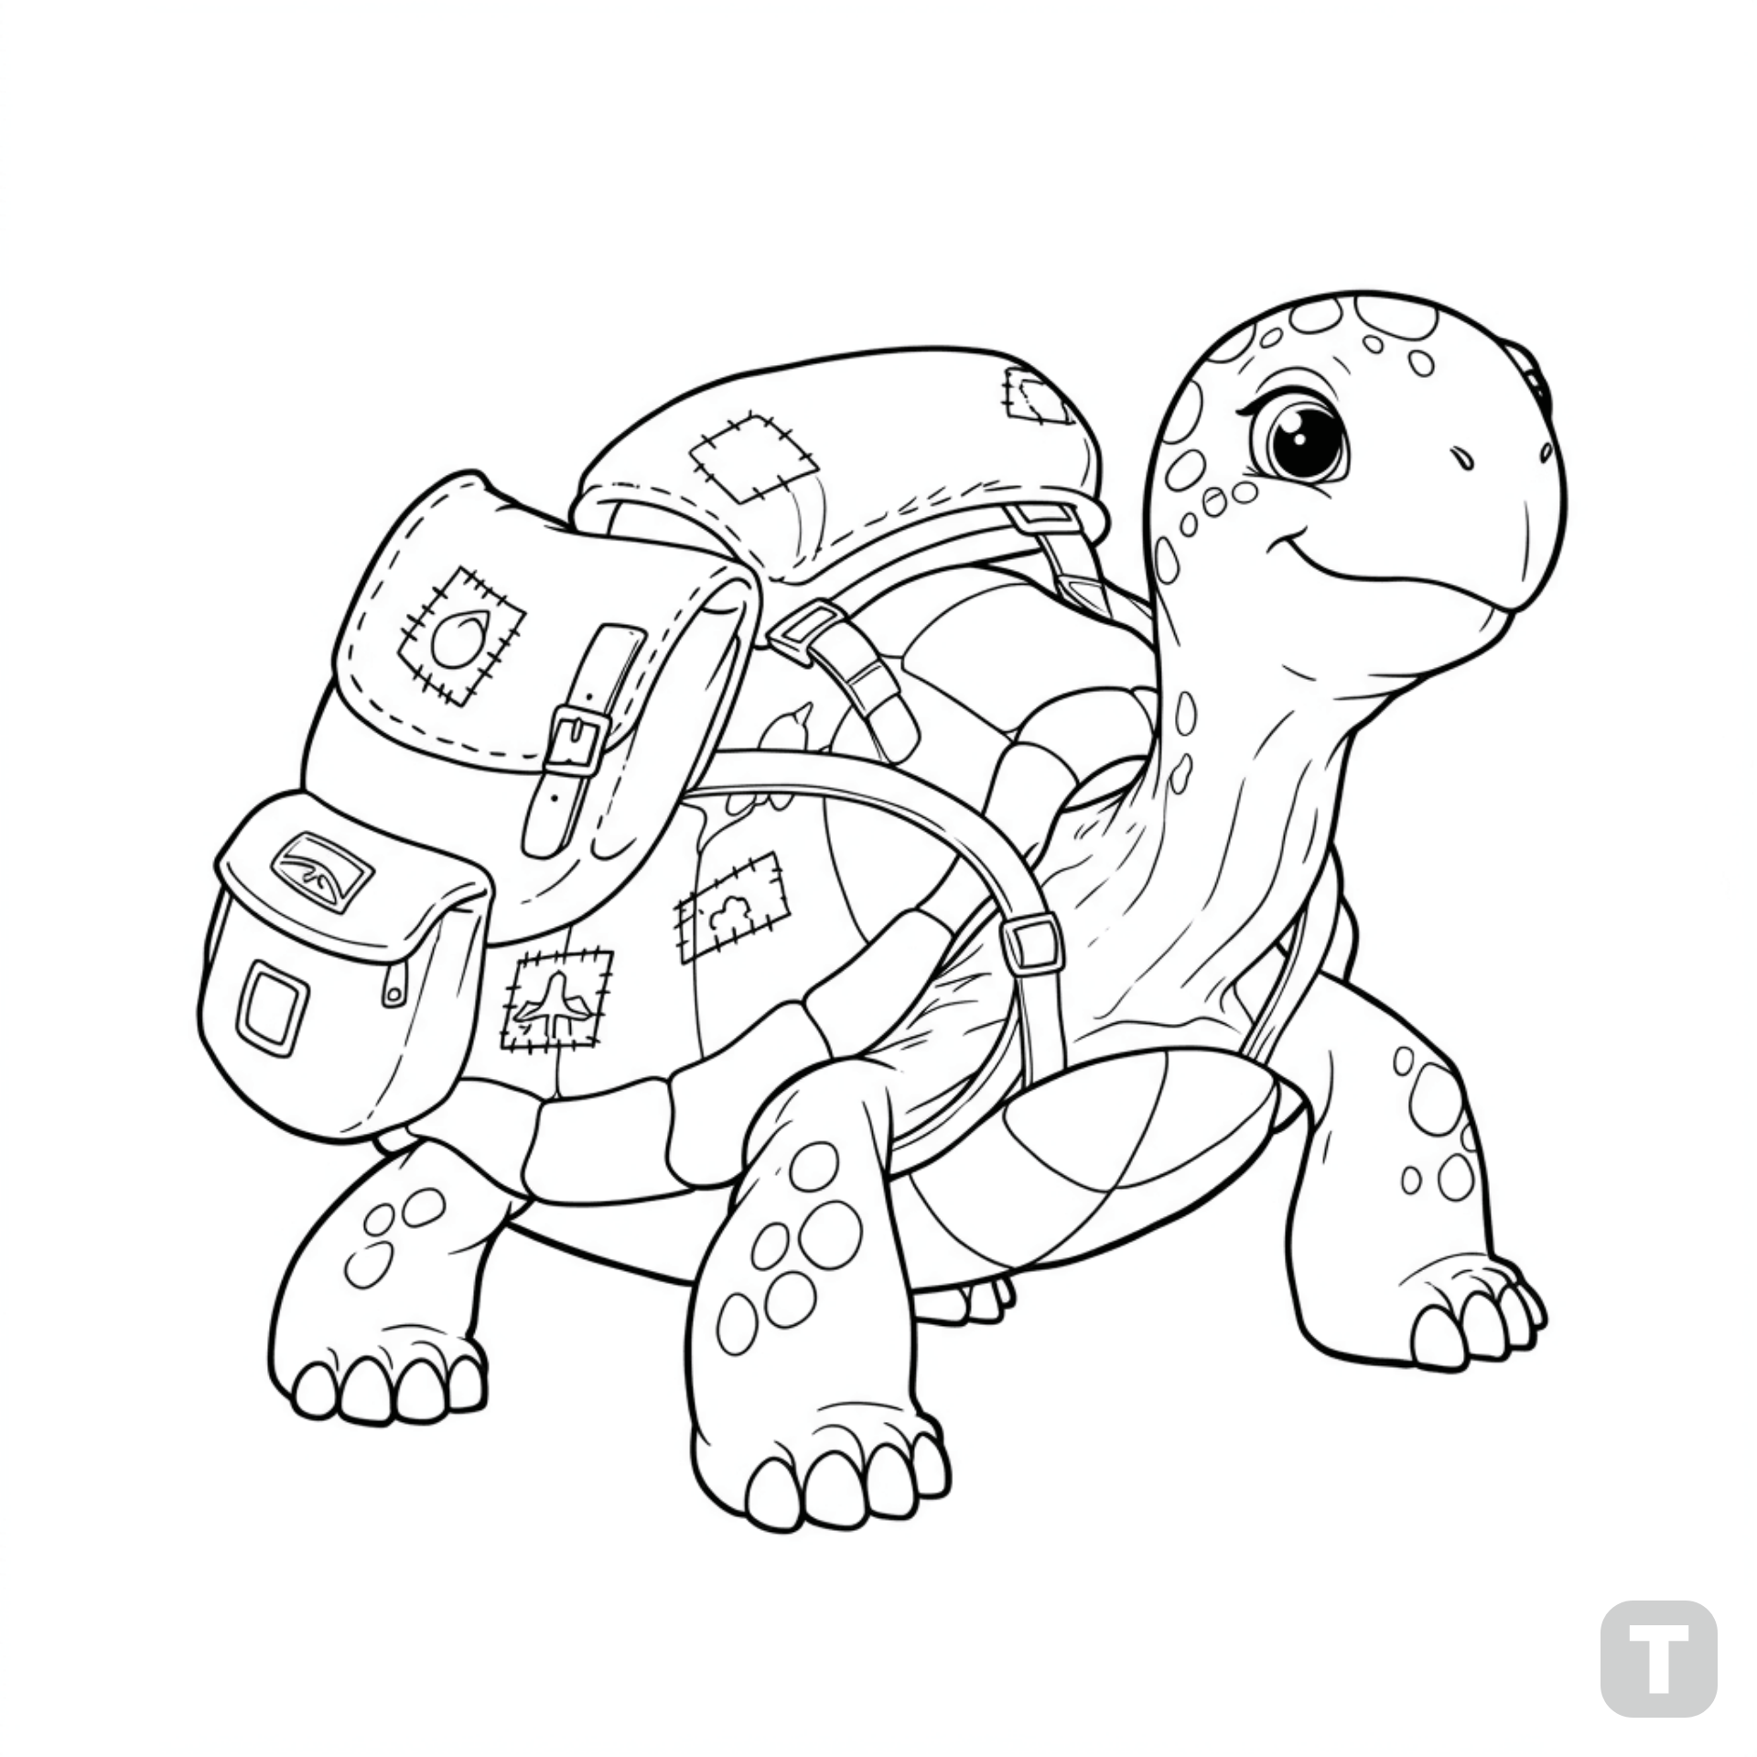

**Turtle with a backpack**

🚗 **V E H I C L E S**

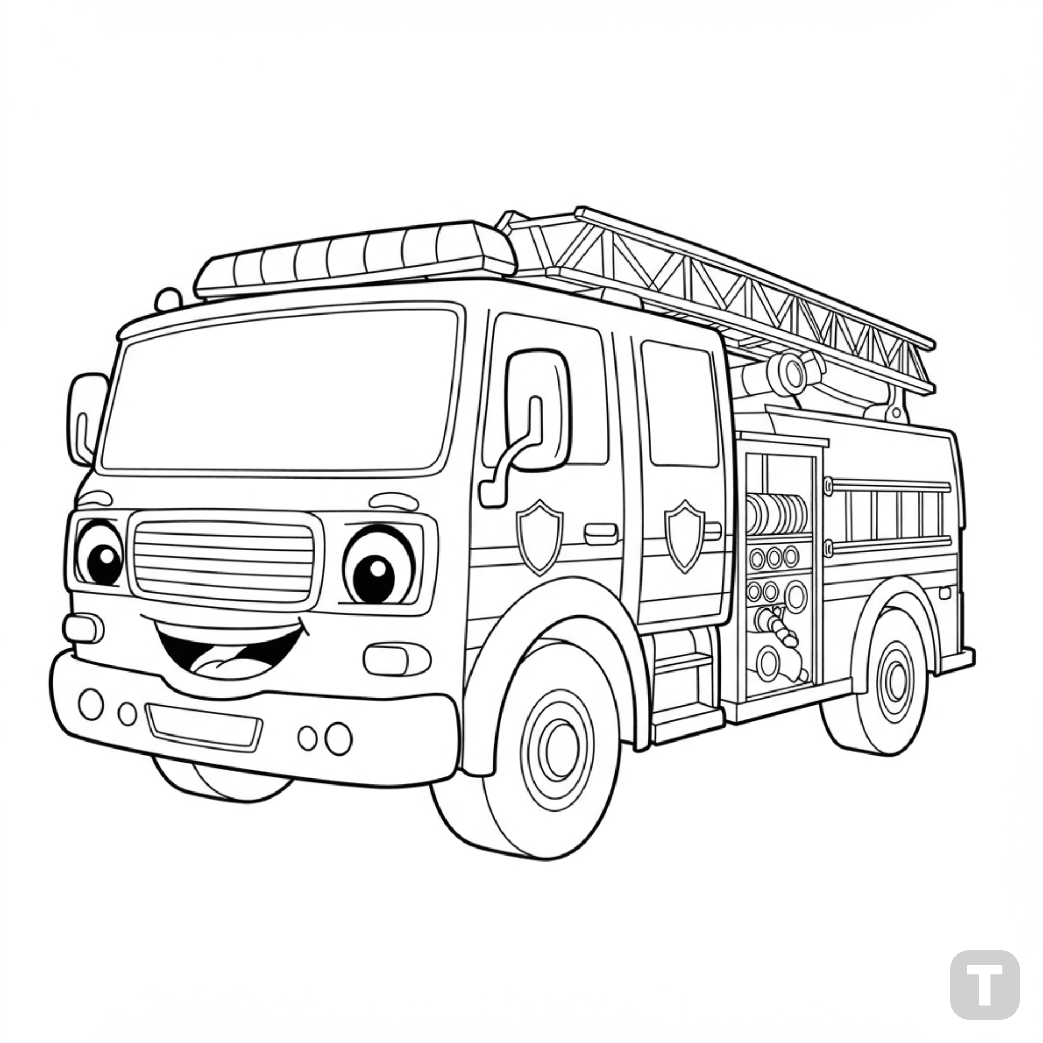

**Fire truck with a smiling face**

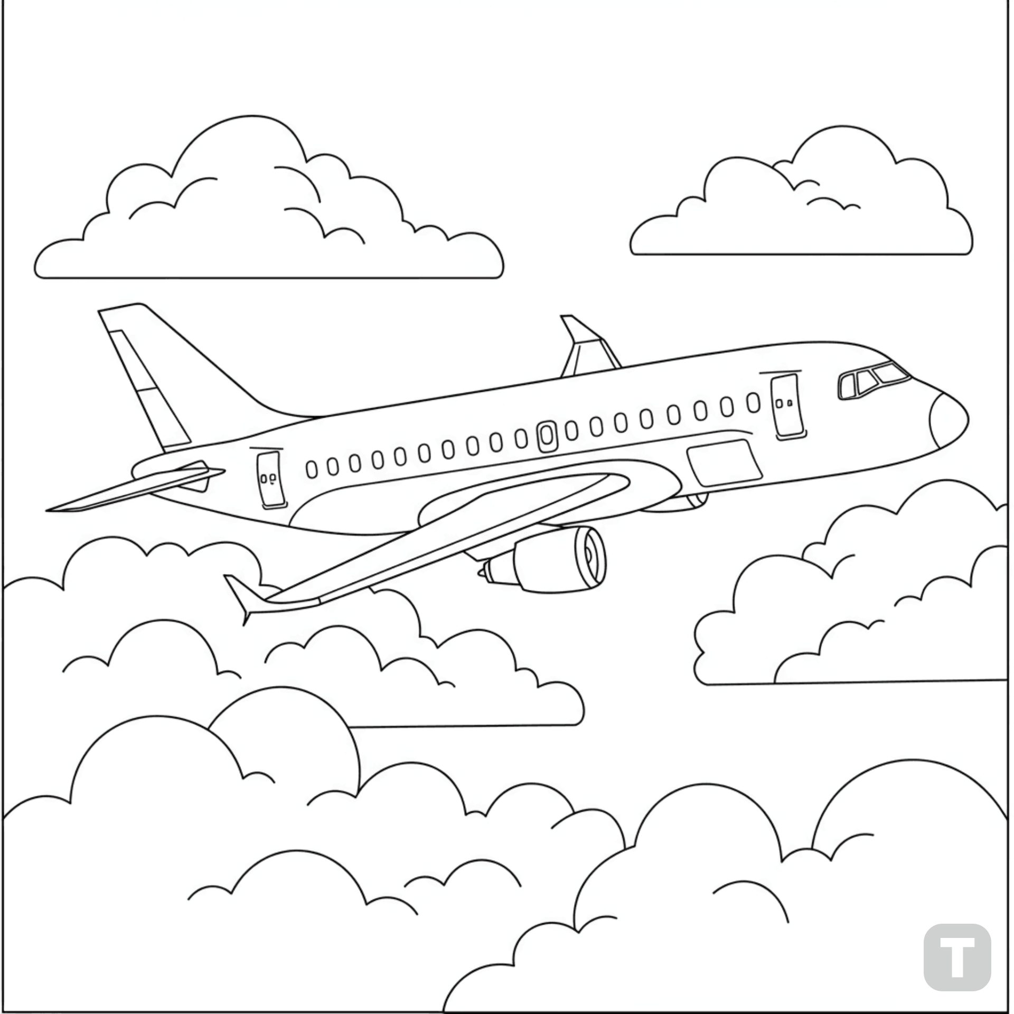

**Airplane flying through clouds**

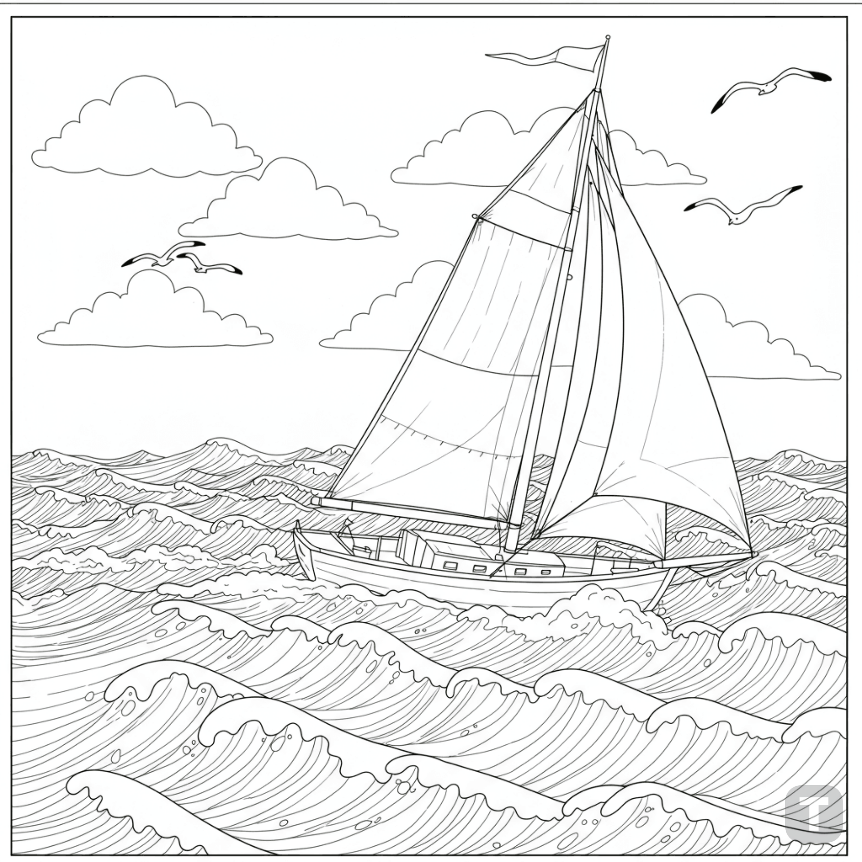

**Sailboat on wavy sea**

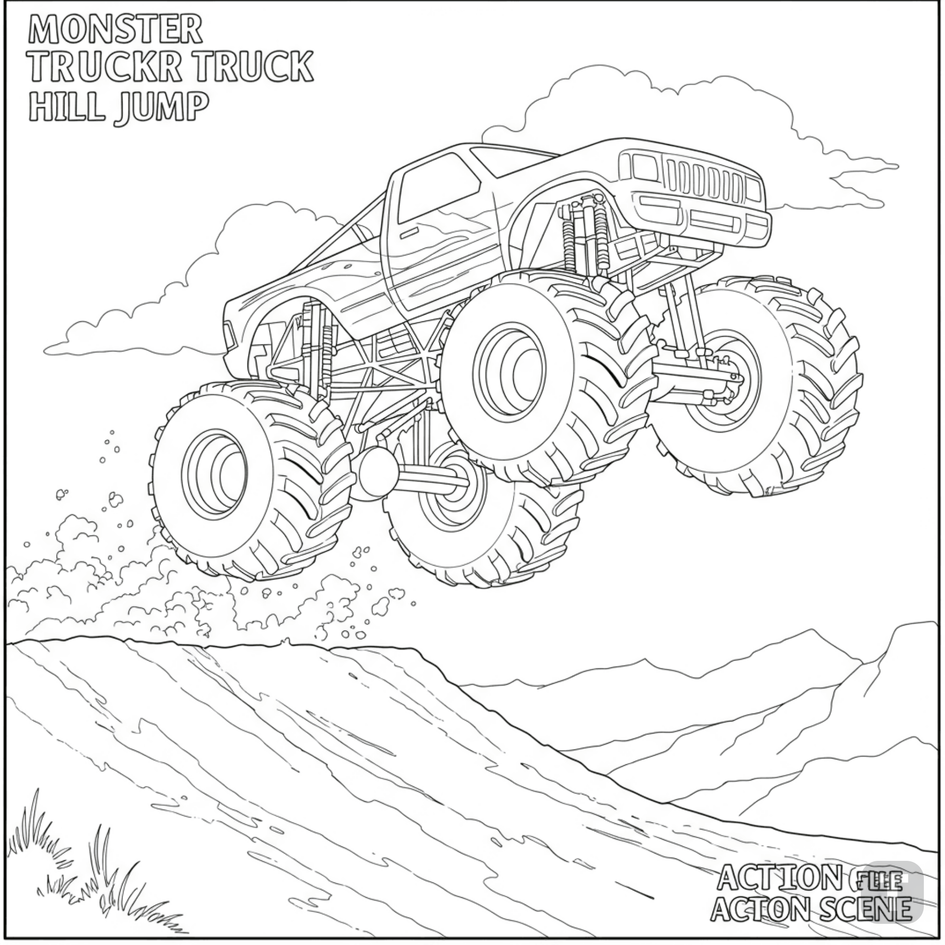

**Monster truck jumping over a hill**

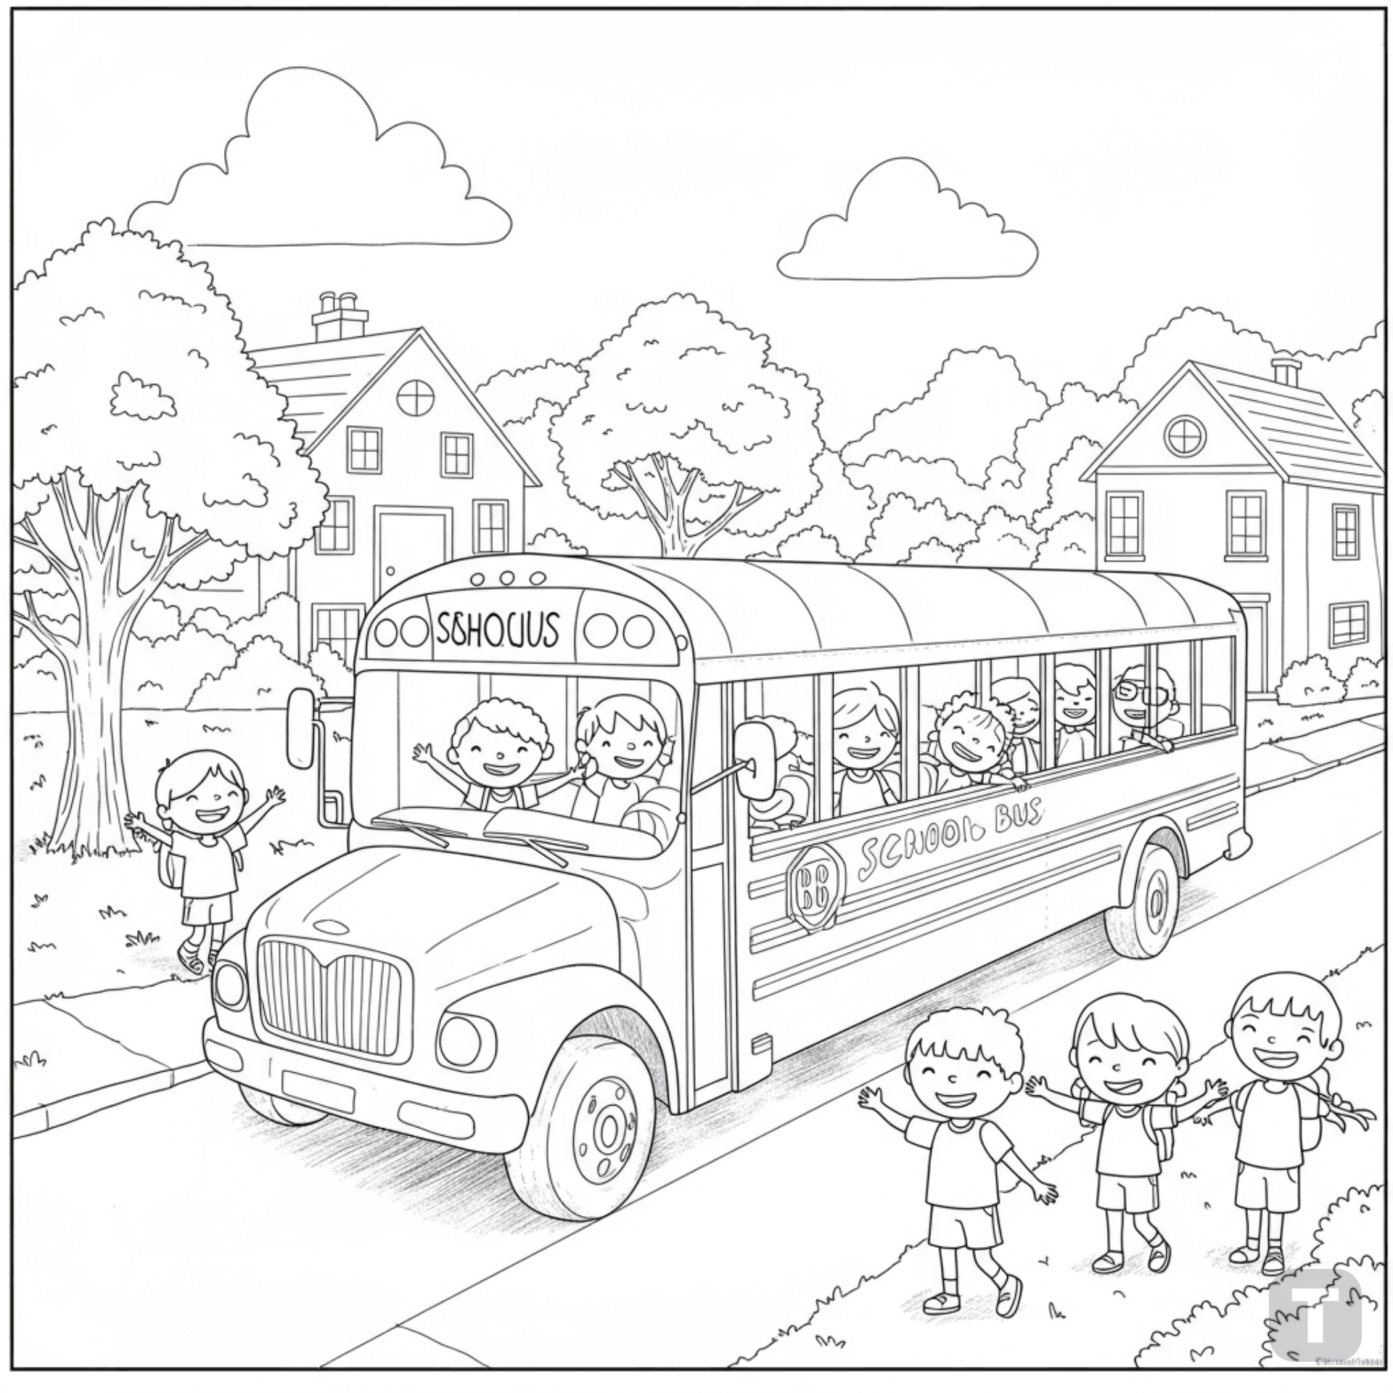

**School bus picking up kids**

**🧠 L E A R N I N G C O N C E P T S**

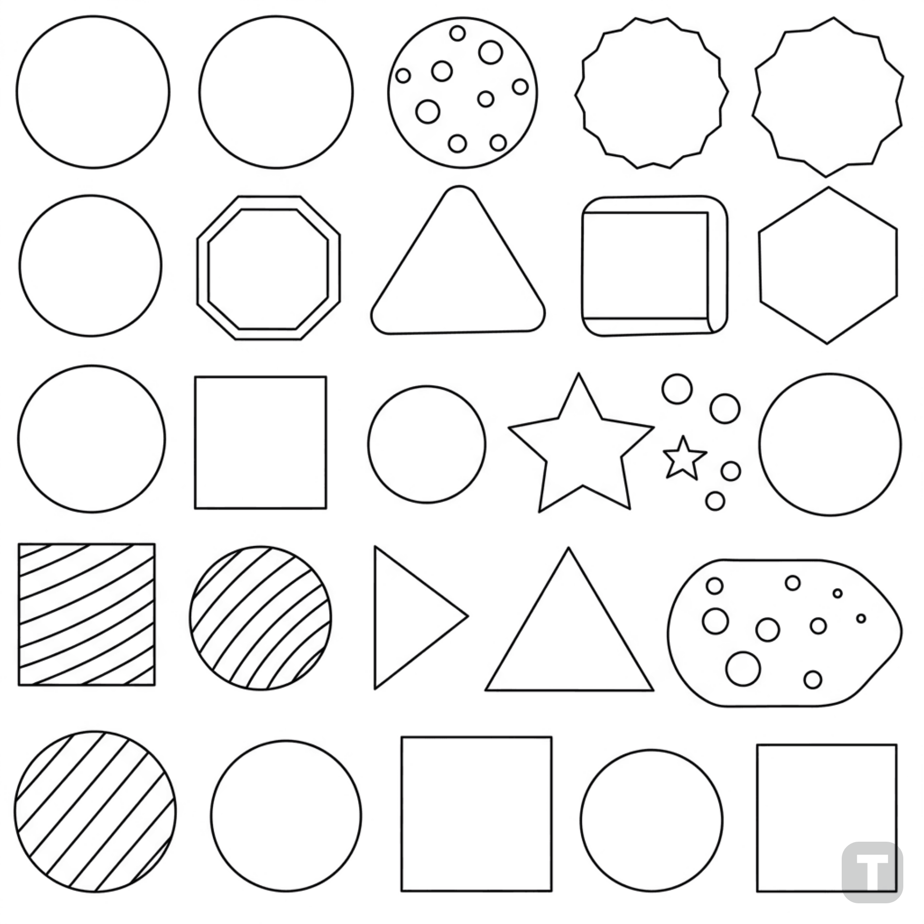

**Shapes and patterns coloring**

👑 F A N T A C Y & F U N

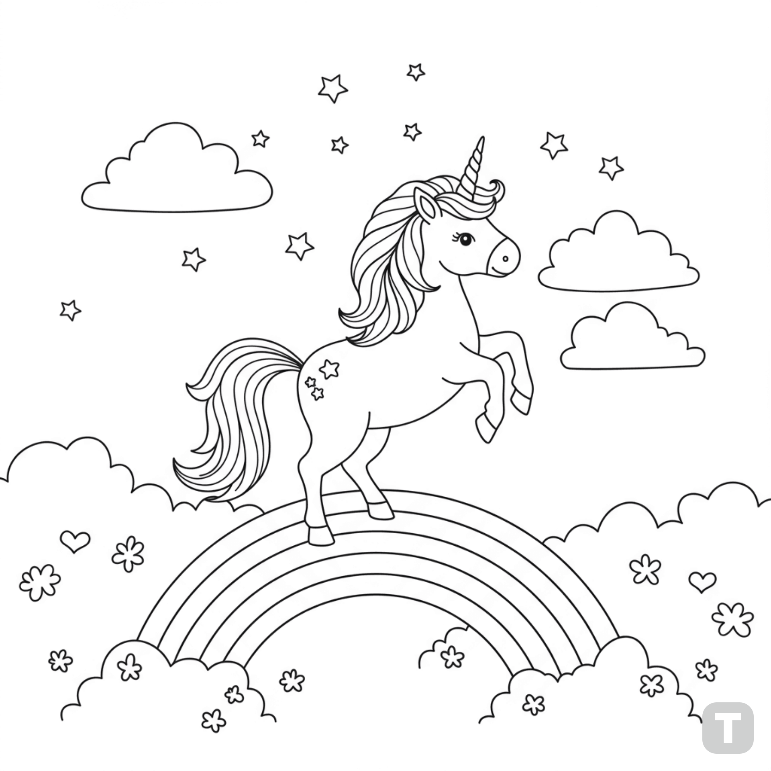

**Unicorn dancing on a rainbow**

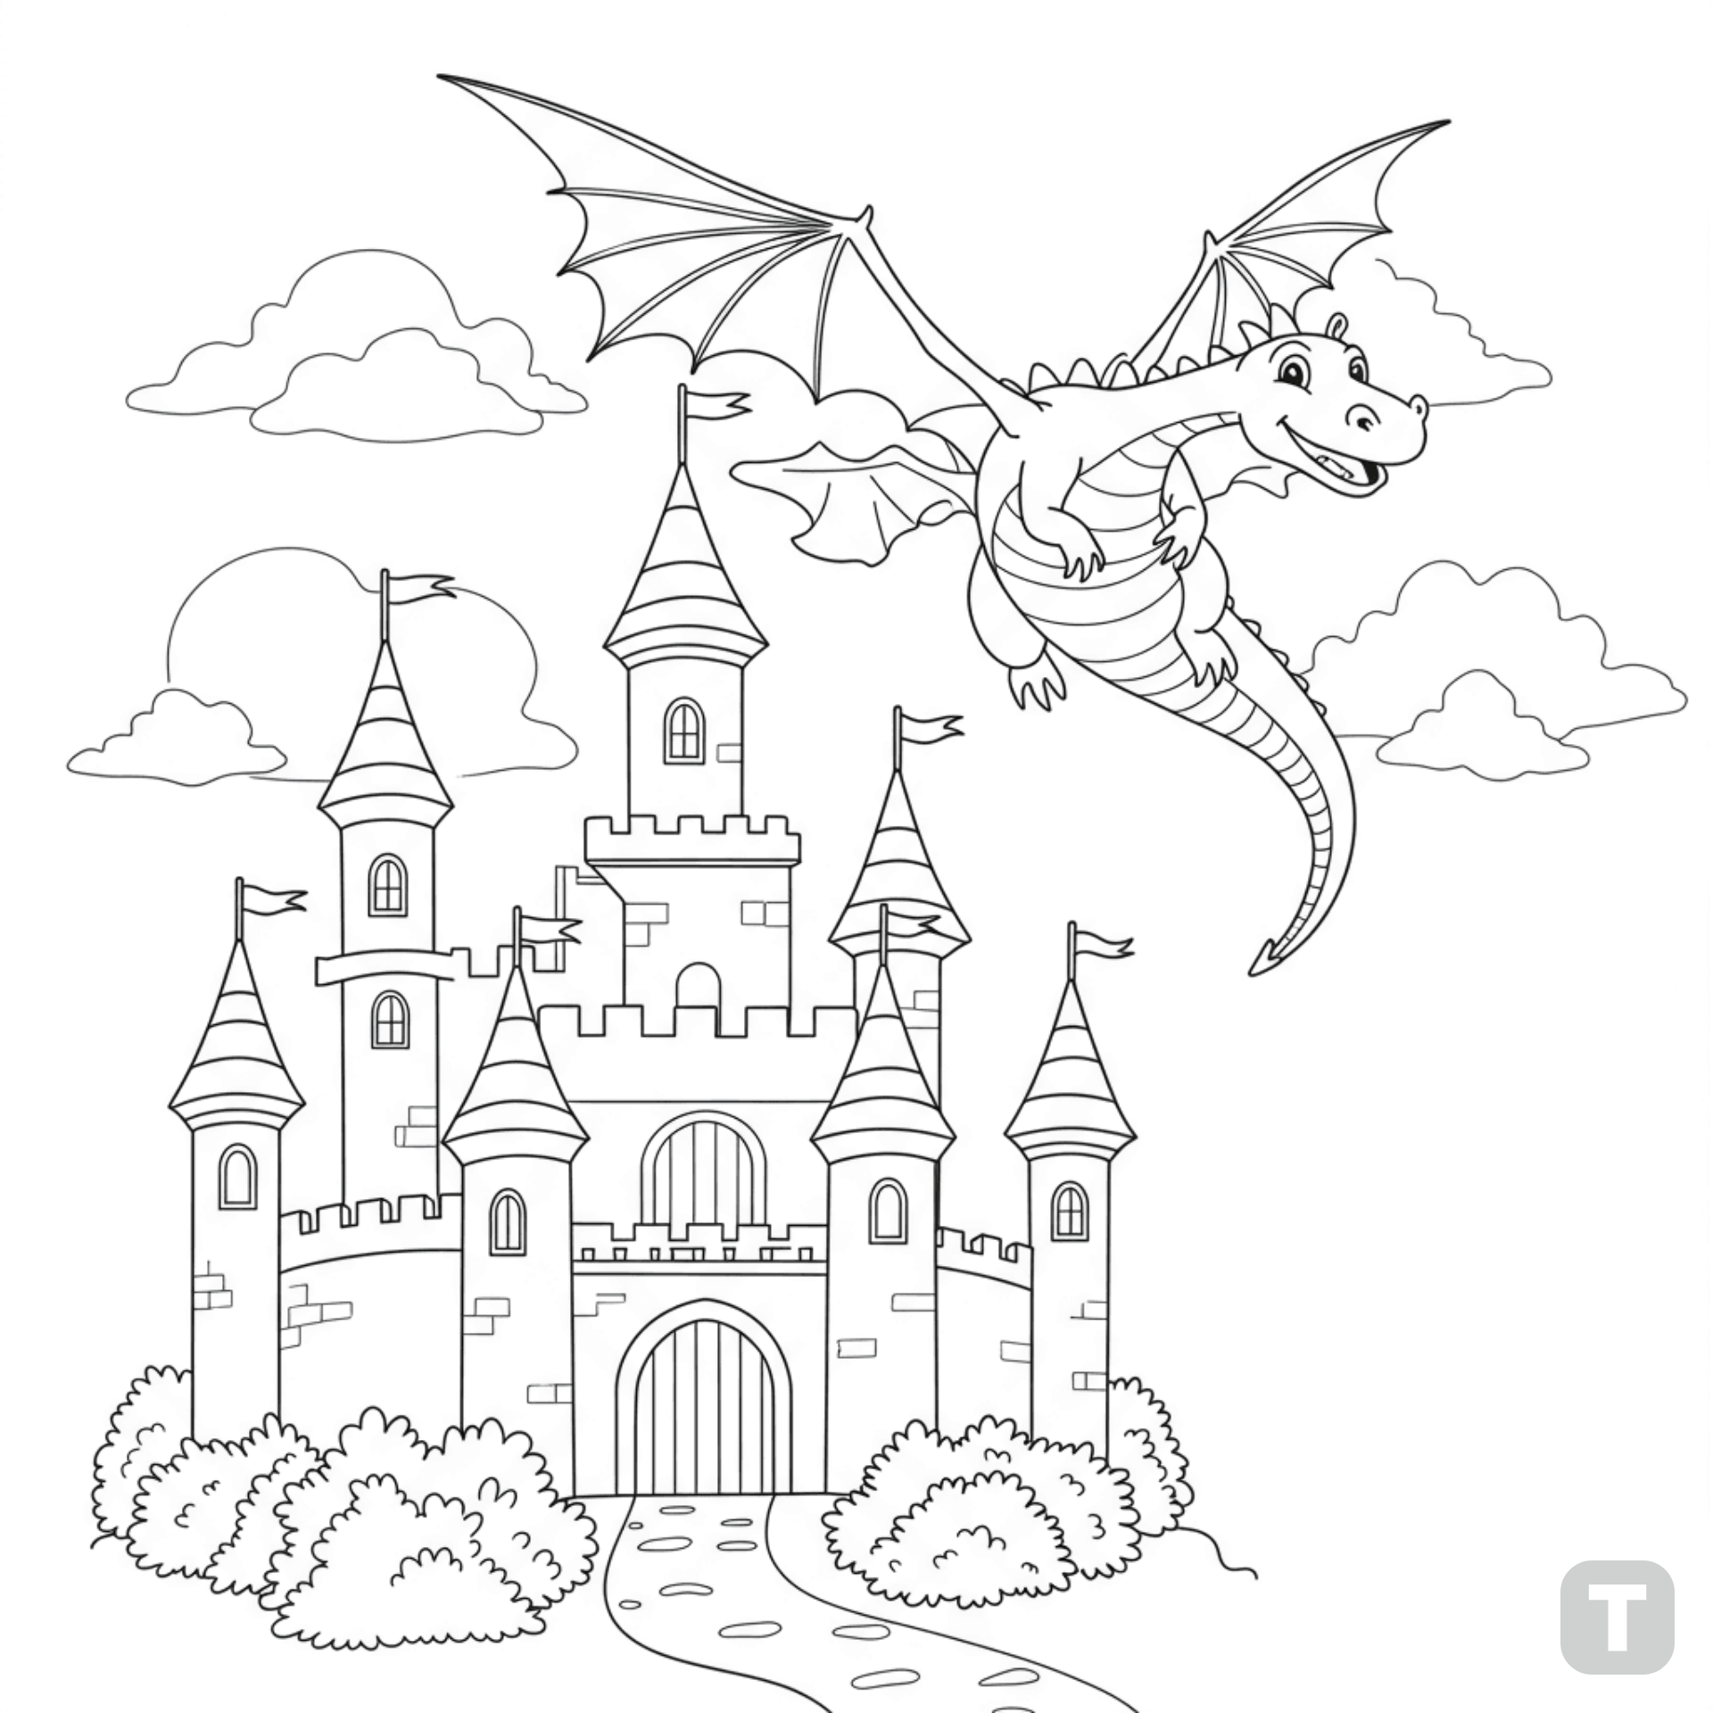

**Castle with a dragon flying above**

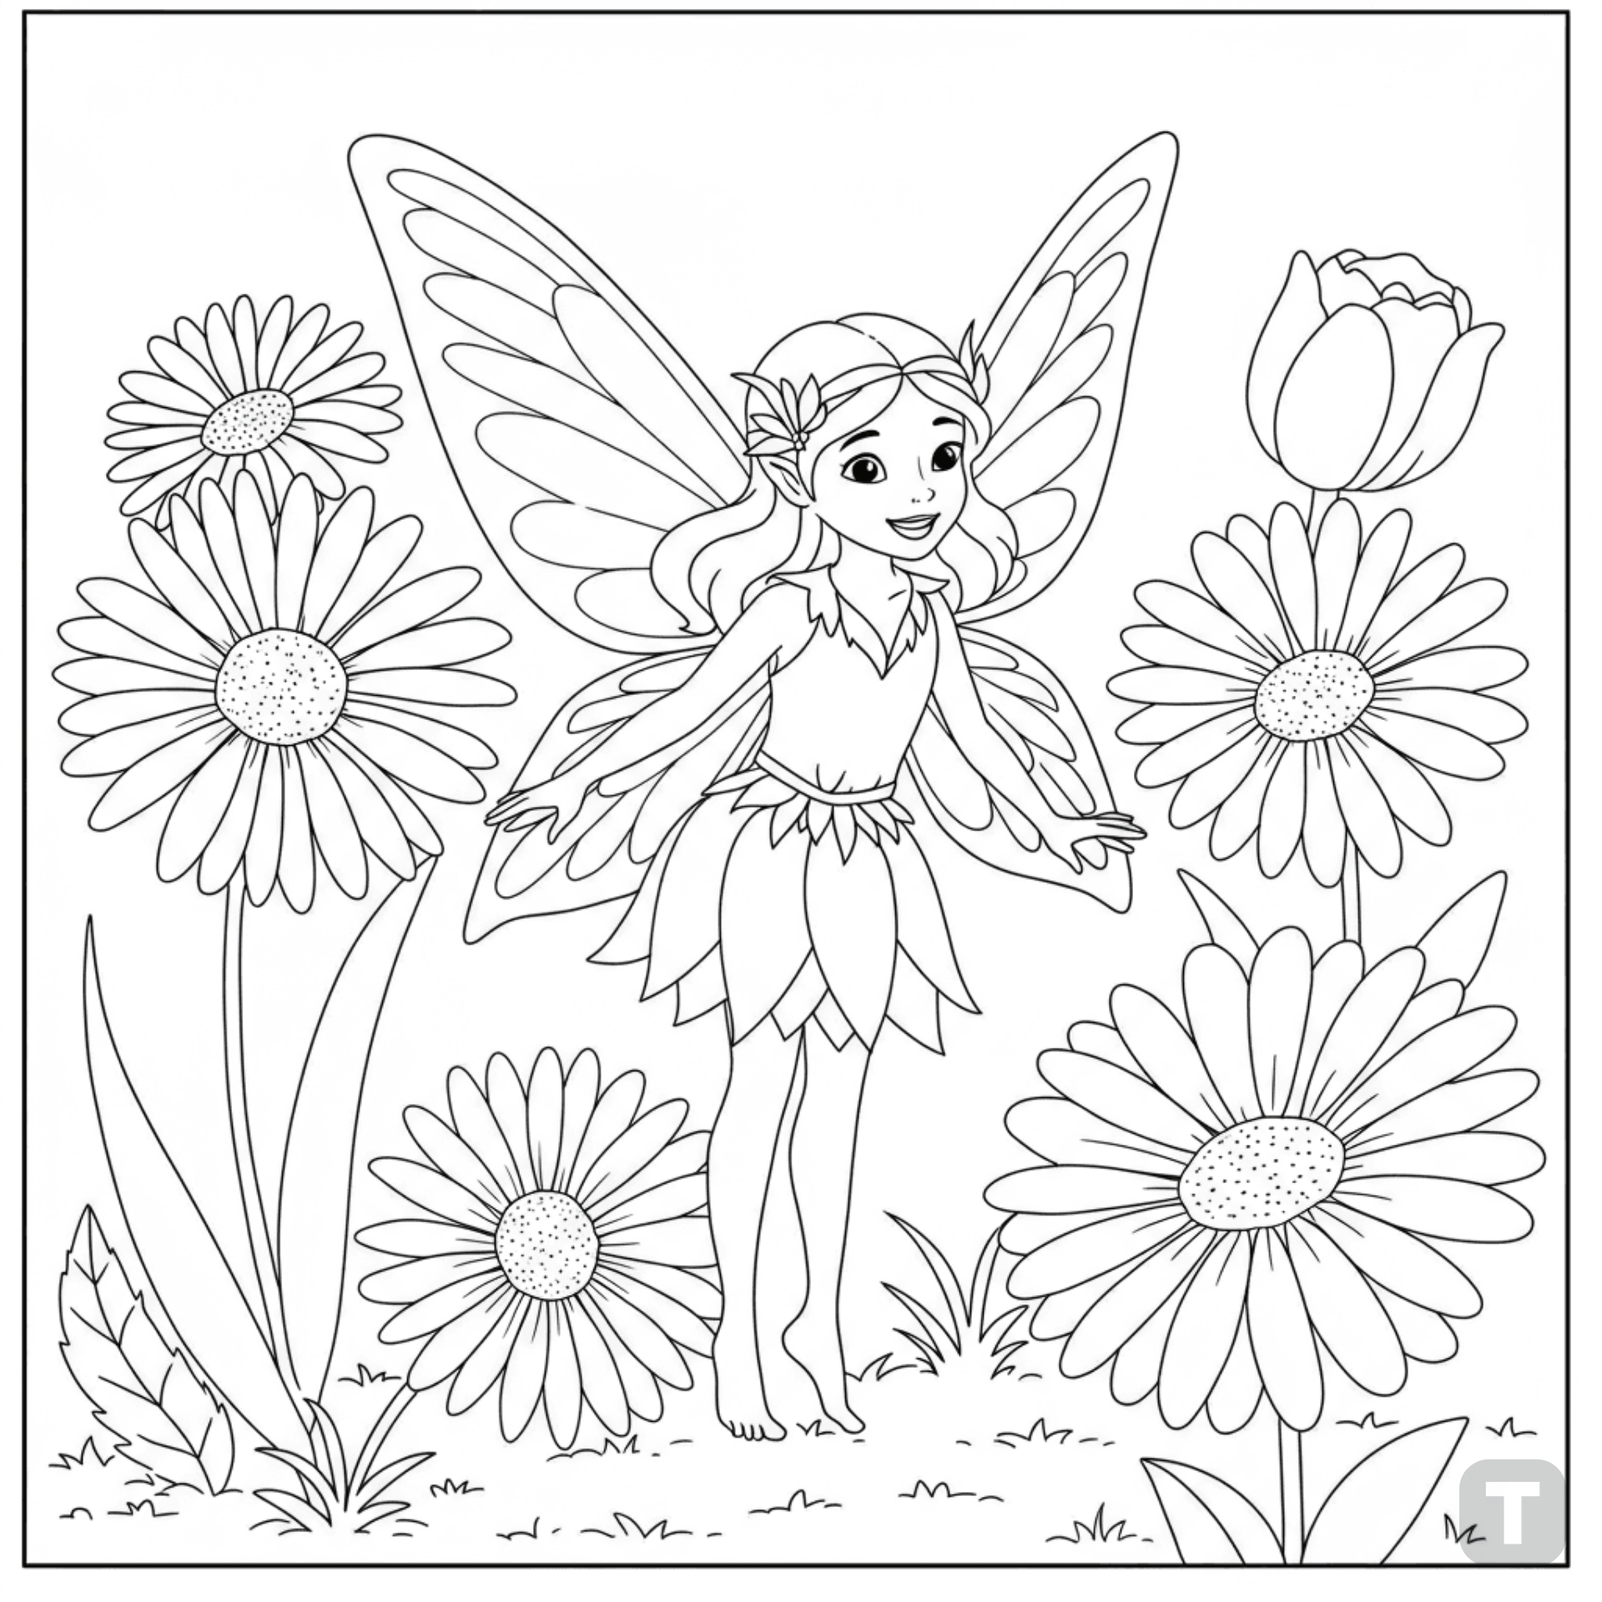

**Fairy in a flower garden**

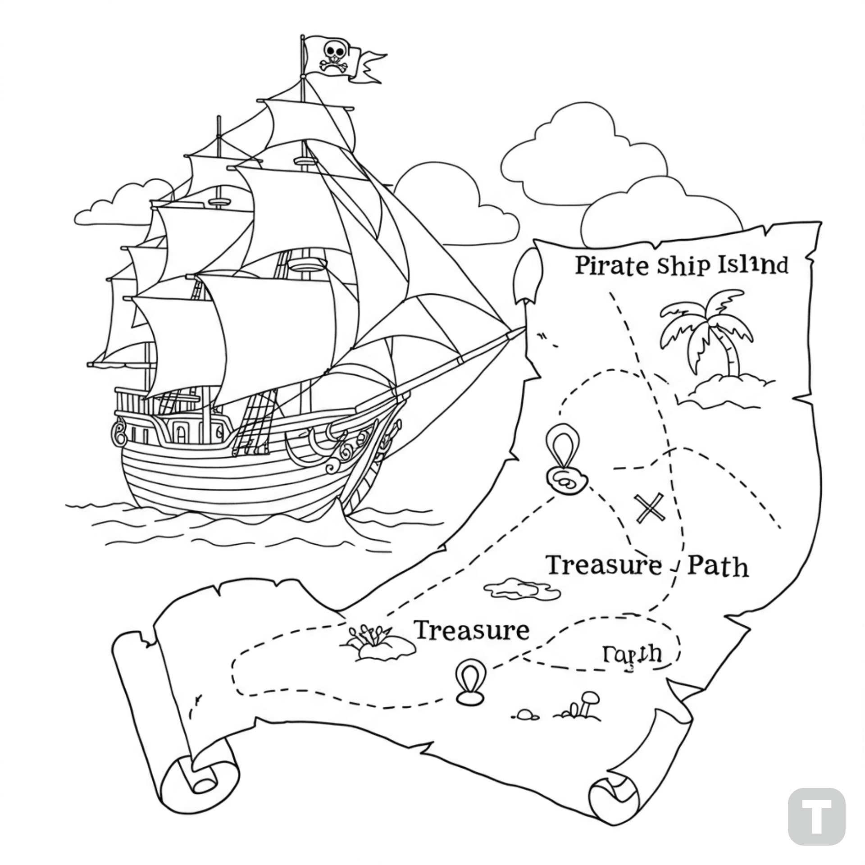

**Pirate ship with a treasure map**

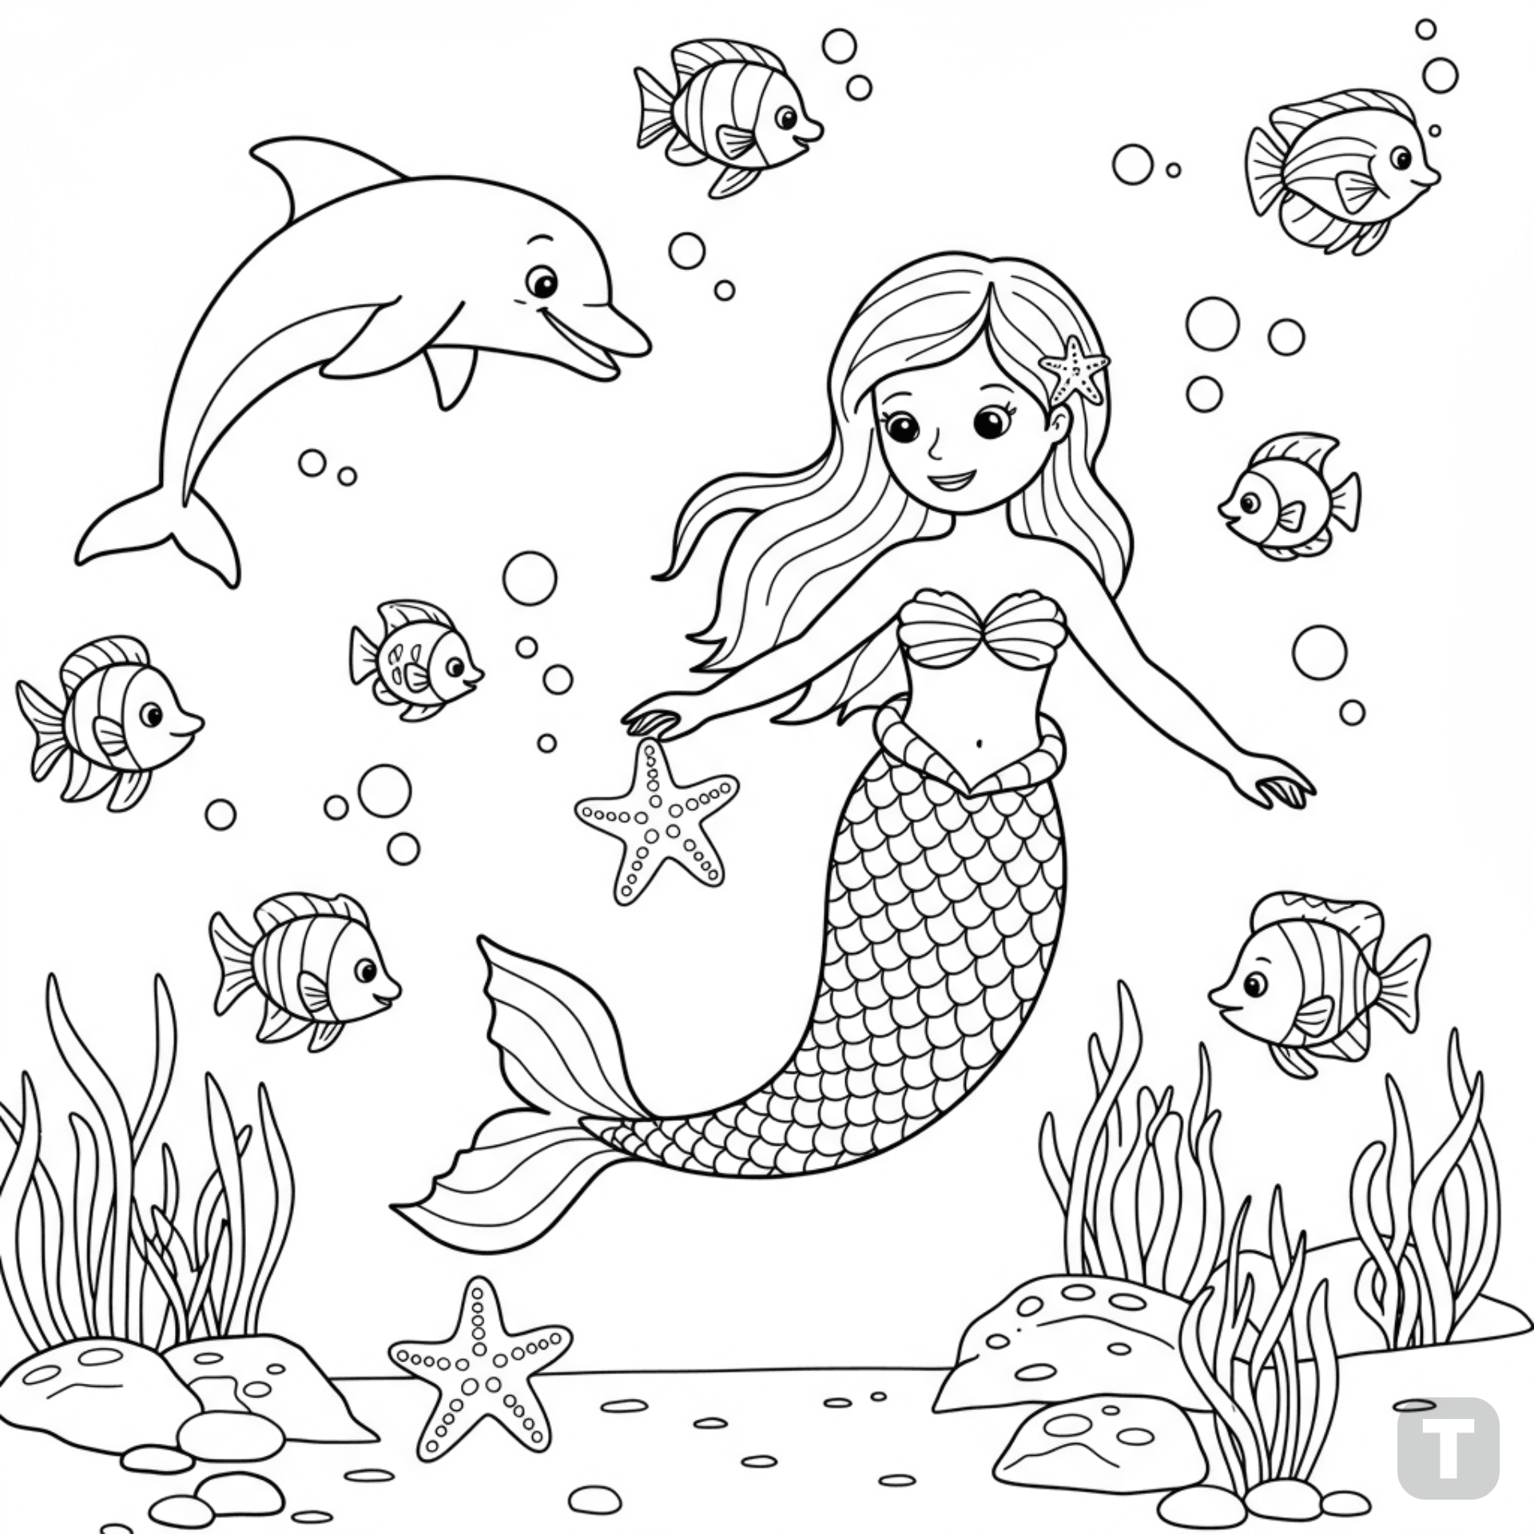

**Mermaid playing with sea creatures**